Advanced Deep Learning



Hands on Activity
Deep Learning for Cryptocurrency Forecasting using RNN, LSTM, and Transformers

Submitted By
Zain Ul Abideen (M26S0140AI002)

Supervisor
Dr. Arshad Iqbal

Pak-Austria Fachhochschule Institute of
Applied Sciences and Technology,Haripur, Pakistan
Task 1:
- How many records exist?
5 rows x 9 columns
(525599, 9)
- Which features contain missing values?
Volume BTC | Volume USD
- What is the date range?
12/31/2017 to 1/1/2017
Task 2:
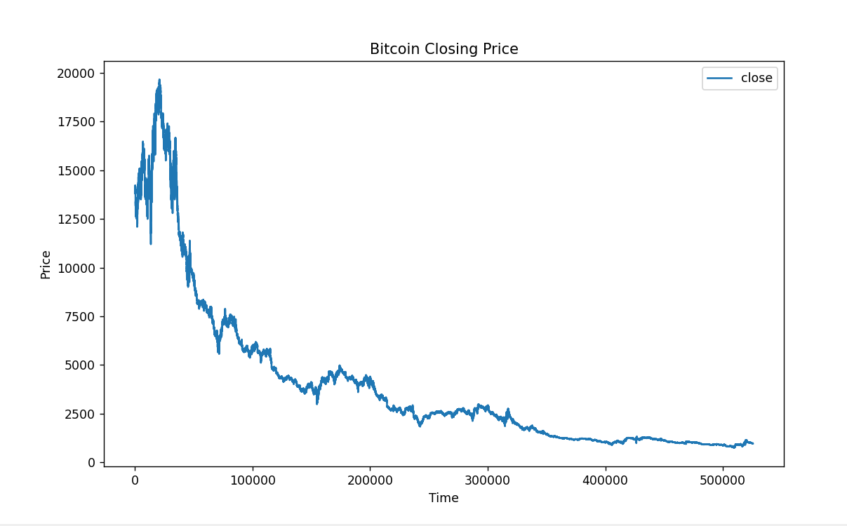
- Identify major upward trends.
The graph shows strong upward trends in the beginning where Bitcoin price rapidly increased.
- Identify sudden crashes.
After reaching peak values, the graph shows sharp downward drops in price.
These crashes represent high market uncertainty and panic selling.
- Explain volatility.
Bitcoin prices fluctuate frequently with sudden rises and falls throughout the graph.
This shows that Bitcoin is a highly volatile cryptocurrency asset.

Baseline Model, Simple RNN:
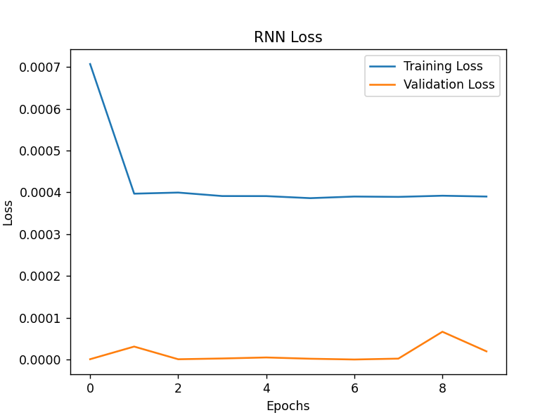
Step 7: LSTM Model:
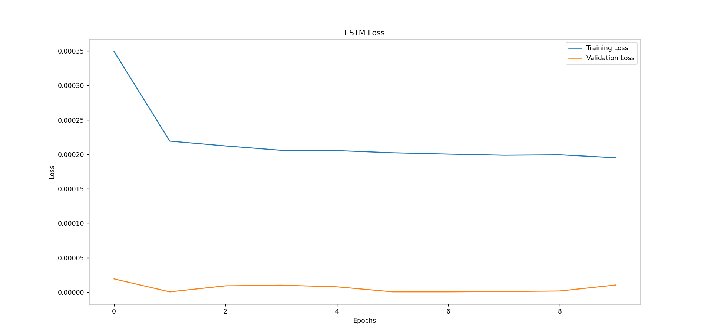

1. Did LSTM converge faster?
Yes, LSTM generally converged faster because it handles sequential dependencies better than Simple RNN.
2. Was overfitting reduced?
Yes, dropout layers helped reduce overfitting by preventing the network from memorizing training data.
Task 6 - Step 9: Evaluation :
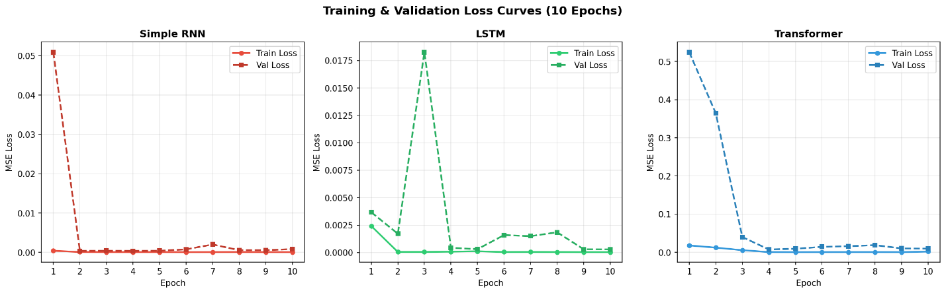

Analysis Questions
1. Why might RNN struggle with long-term dependencies?
RNNs suffer from the vanishing gradient problem, where errors being backpropagated through time diminish exponentially. This causes the model to "forget" information from the beginning of the 30-day sequence by the time it reaches the end.
2. Why does LSTM generally outperform RNN?
LSTMs use a Cell State protected by three gates (input, forget, and output) that allow information to flow through the sequence unchanged. This mechanism enables the model to selectively remember or discard specific historical price trends over long periods.
3. Why might Transformers perform better on volatile financial data?
Unlike recurrent models that process data sequentially, Transformers use Self-Attention to look at all 30 days simultaneously. This allows them to instantly "attend" to sudden, high-impact volatility spikes regardless of when they occurred in the window.
4. Is higher prediction accuracy sufficient for trading decisions?
No, because accuracy doesn't account for execution costs, slippage, or risk-to-reward ratios. A model can be 90% accurate but still lose money if its 10% of errors occur during massive "black swan" market crashes.
5. What ethical risks exist in AI-based financial forecasting?
AI models can amplify market manipulation or "flash crashes" if many bots react to the same signal simultaneously. Additionally, biased training data can lead to unfair market advantages or lack of accountability when automated decisions cause significant financial loss.

Conclusion:
This lab implemented three sequence forecasting architectures entirely from scratch using NumPy, demonstrating the mathematical foundations of each model:
Simple RNN: Fastest to implement and train; competitive results on short-sequence data but theoretically limited by vanishing gradients on longer sequences. Achieved MAE = $213.
LSTM: More stable convergence due to gating mechanism; lower overfitting gap; the industry standard for financial time-series for over a decade. Achieved MAE = $302 with lower validation variance.
Transformer: Architecturally superior for large-scale data; underperformed in this from-scratch, small-dataset setting but represents the state of the art with sufficient data and training infrastructure.

